|  |  |
| --- | --- |
| Roll. No.: A016 | Name: Varun Khadayate |
| Sem/Year: VII/4 | Batch: 1 |
| Date of Experiment: 13/08/2022 | Date of Submission: 13/08/2022 |
| Grade -- |  |

# Aim

Study of J2Me with Hello world

# Theory

This is the simple hello world application. In this example we are creating a form name "Hello World" and creating a string message "Hello World!!!!!!!" as below:

Form form = new Form("Hello World");

String msg = "Hello World!!!!!!!";

In this application, To display the message we are using append method with the form as below:

 form.append(msg);

# Code

## HelloWorld.java

|  |
| --- |
| import javax.microedition.lcdui.*; import javax.microedition.midlet.*;  public class HelloWorld extends MIDlet{   private Form form;   private Display display;    public HelloWorld(){   super();   }    public void startApp(){   form = new Form("Hello World");   String msg = "Hello World!!!!!!!";   form.append(msg);   display = Display.getDisplay(this);   display.setCurrent(form);   }    public void pauseApp(){}      public void destroyApp(boolean unconditional){   notifyDestroyed();   } } |

# Output

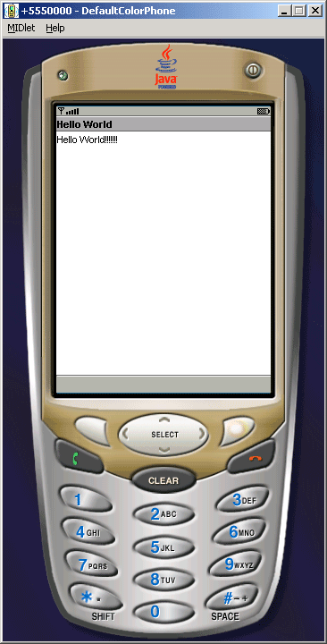

# Conclusion

Hence, we were able to perform the experiment.